Who: Incoming 3rd – 9th grade BOYS & GIRLS
When: June 6- June 9, 2022, 9am-12pm
Where: Bowie High School, 2101 Highbank Dr, Arlington
Cost: $50 Registration on or before June 1
$60 Registration after June 1
Cost Includes: Camp T-shirt
**FREE BREAKFAST & LUNCH** **PROVIDED FOR ALL CAMPERS!!**
Concessions and Alternative Lunch items will be available for sale
Bowie Camp Directors:
-Allen Gratts, Bowie High school, Head Mens Basketball Coach (682) 553-1248
- Kelly Carruthers Bowie High School, Head Womens Basketball Coach (817) 822-6288
-Dayton Barone, Bowie High School, Assistant Mens Basketball Coach (817) 894-0766

Whether you’re looking for a fun filled week of hoops, or are serious about improving your game, this is the camp for you! Work with current Bowie and college athletes, as well as, possibly current and former pros and college coaches to step your game up!

For Inquires contact: Bowiebasketballcamp@gmail.com or text Coach Barone @ 817-894-0766
Email completed form to Bowiebasketballcamp@gmail.com or mail to:
2101 Highbank Dr, Arlington, TX 76018, ATTN: Dayton Barone
__________________________________________________________

Name ________________________Age ____ Date of Birth: _____/_______/_______ (Check one) M___Female___
Address ________________________________________ City ______________ State _______ Zip____________
Parent(Guardian) Name___________________________________ Parent’s Cell ( __) _______
Parent Email _______________________________________________ Grade (Fall 2022) __________________
T-Shirt Size (circle one) Youth Sizes: S M L Adult Sizes: S M L XL XXL
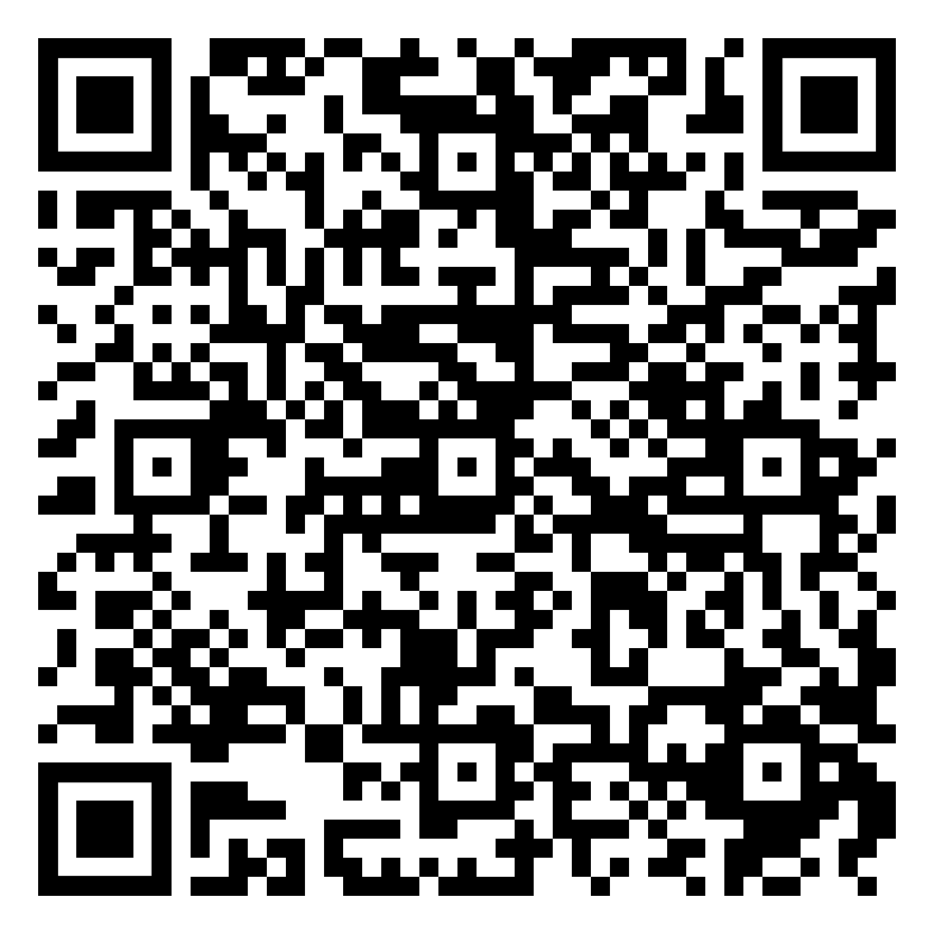
Scan Here to Register!

