2022-23 Application Instructions
- Go to https://www.aisd.net/martin-high-school/stem-academy-at-martin-high-school/ and click apply now.
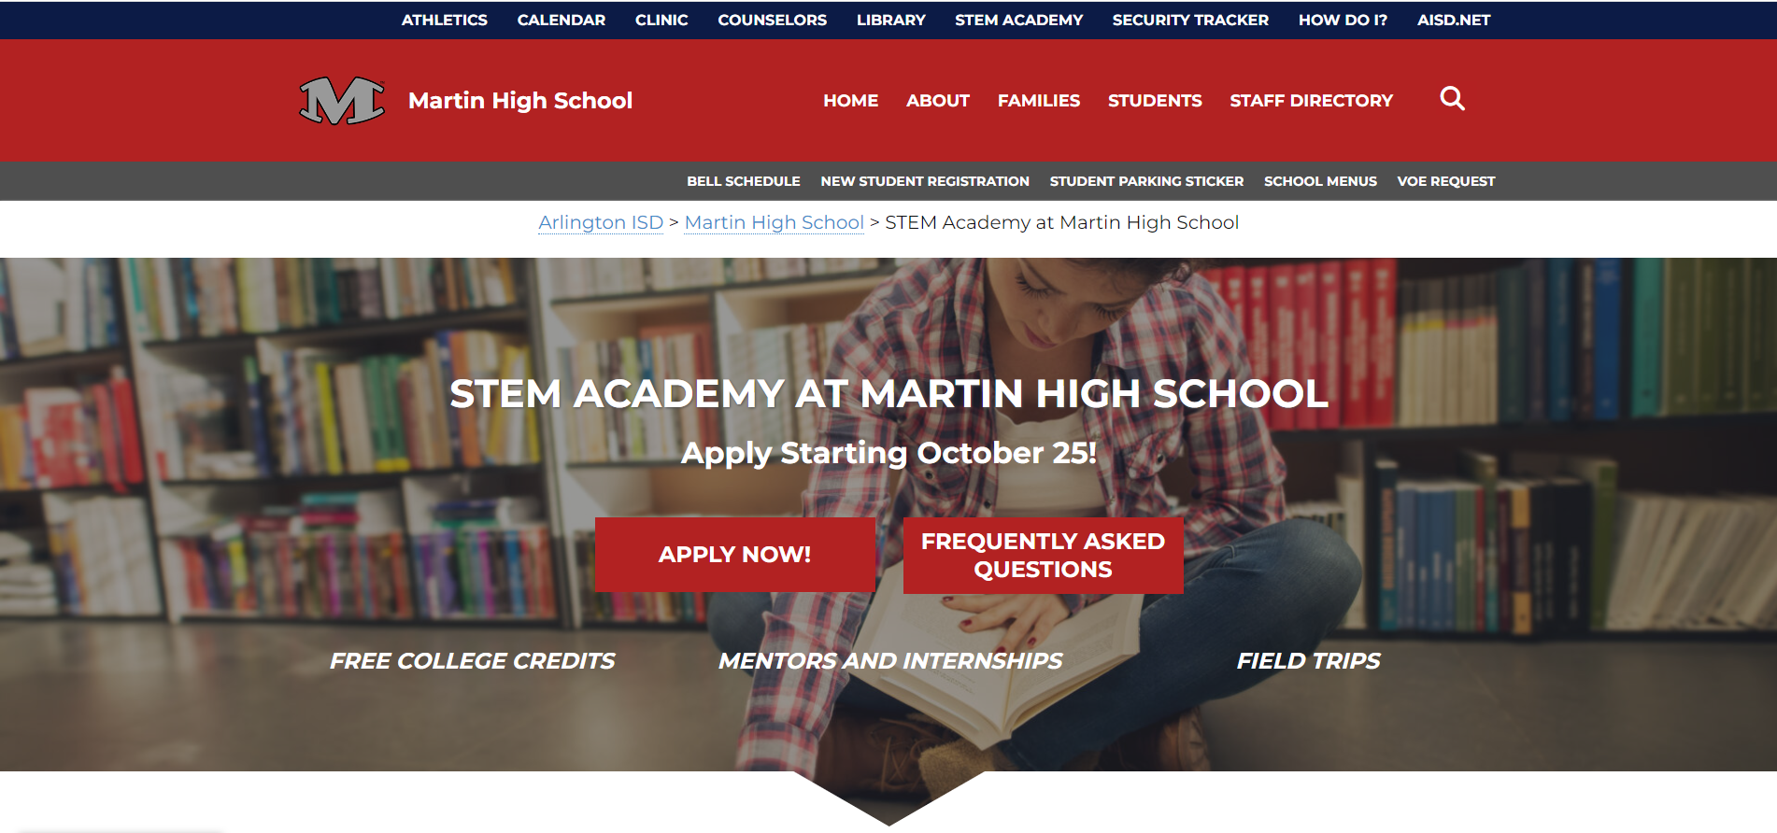
- Once you are on the Secondary Specialized Programs Application page, click “Please Register”.

- Once you are on the Parent/Guardian Registration page, fill out the information requested, and hit submit.
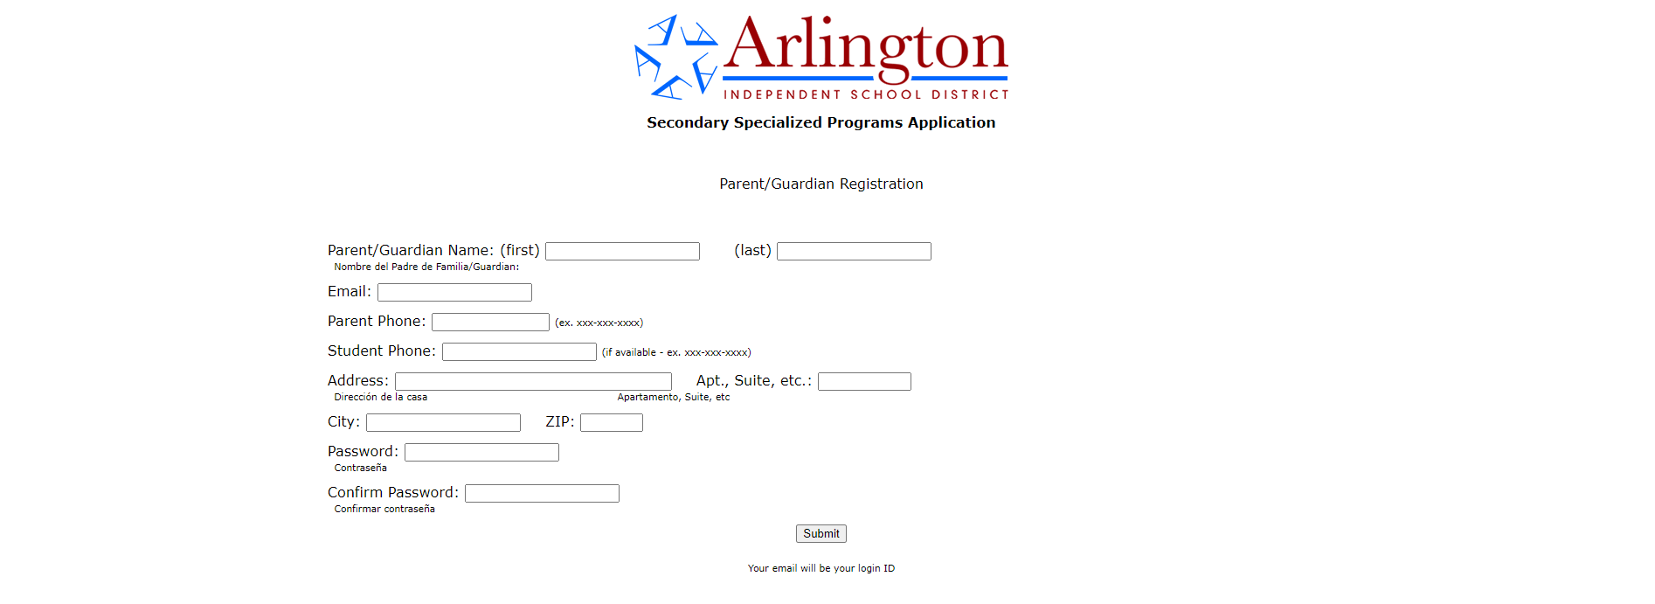
- Once you have registered, login with the email and password you setup, and select “click here for main application”.
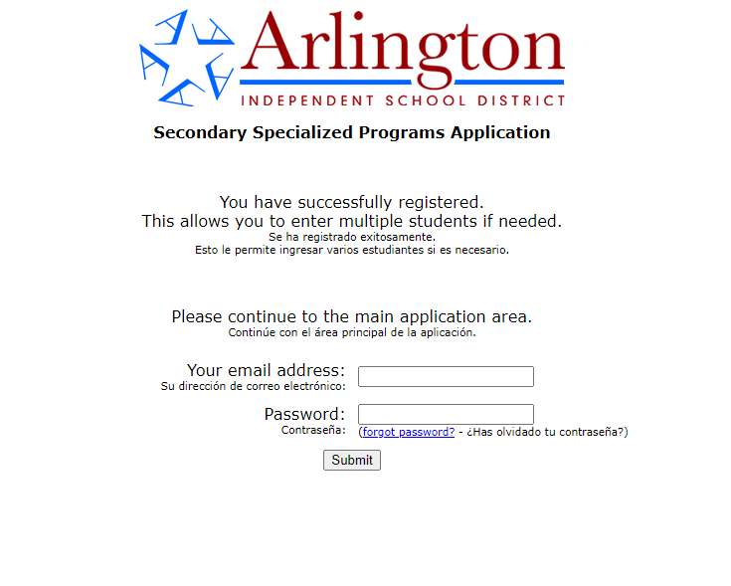
- Then select the option that applies to you.
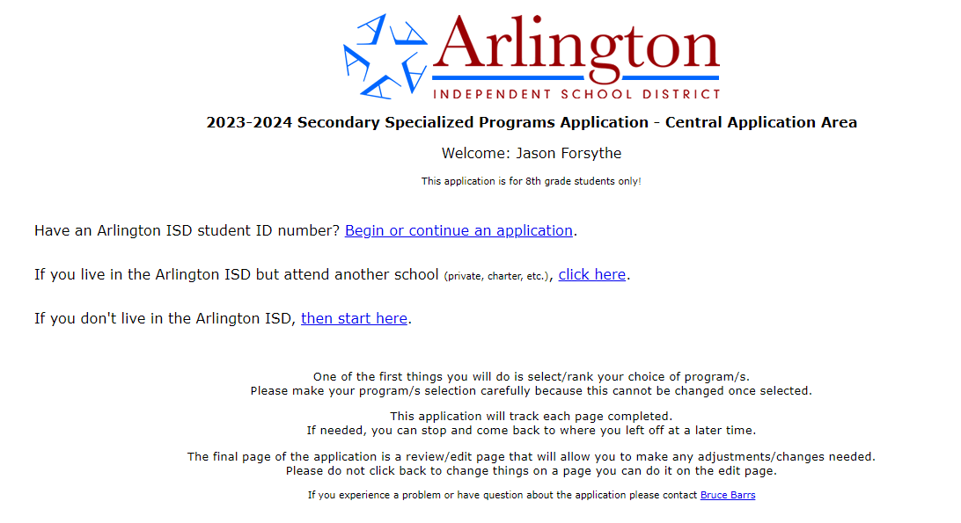
Do not live in AISD.
If you live in the district, but DO NOT attend and AISD school.
Select if you live in the district and attend an AISD school.
- Fill out student Demographic information, and hit submit.
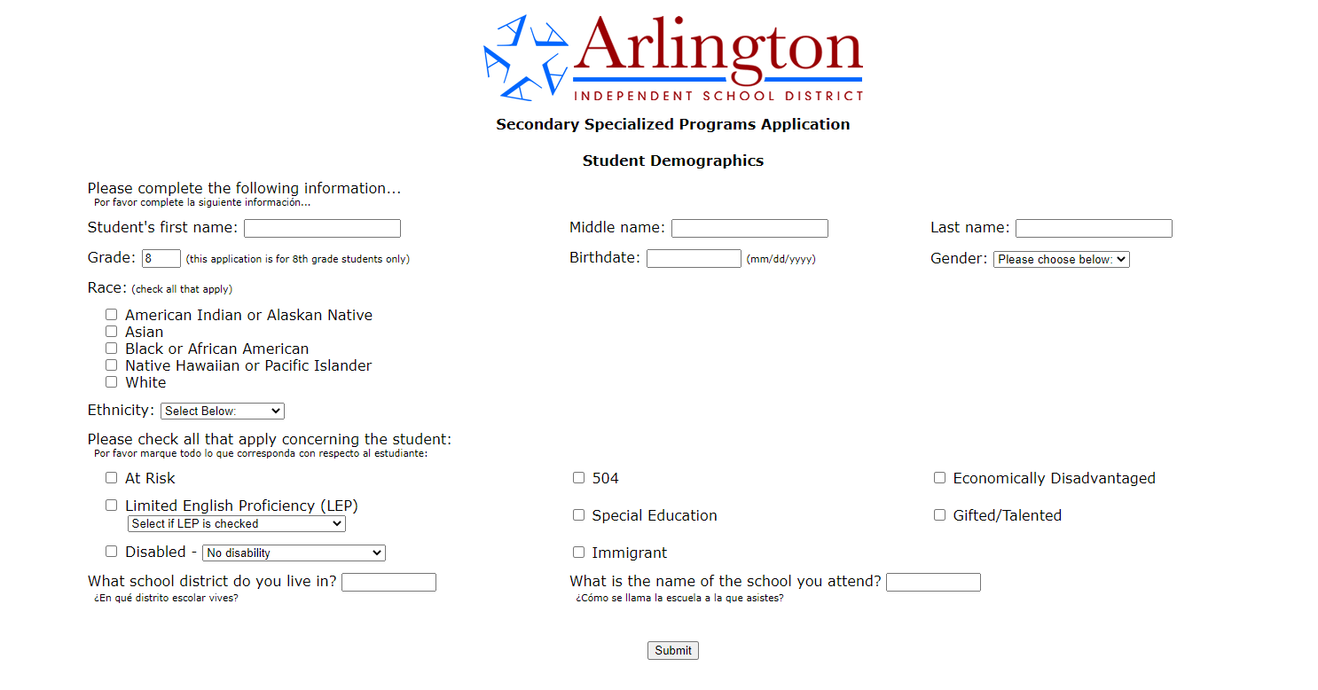

- Select “STEM Academy at Martin High School” as your first choice. If you would like to be considered for other programs as well, rank them appropriately. You may select up to three (3), but you only have to select one (1). Once you hit submit, you cannot change your selections.
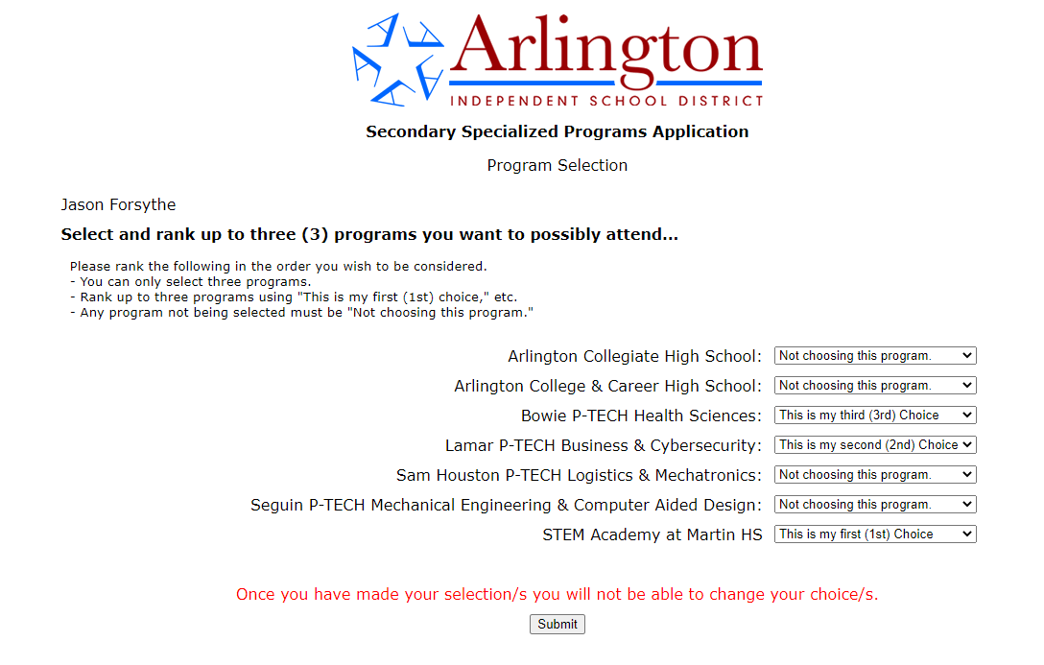
- After you hit submit, you will be directed to the applications of the programs you selected. If you just select the STEM Academy, you will only be directed to the STEM Academy Application. Complete the Application questions and click submit.

