For any Security Systems Requests, to include badges, camera issues, access control issues, alarm system issues, CCTV requests, etc., please follow the steps below:

Link to Help Ticket System: https://arlingtonprod.service-now.com/
To Login to Service Now: Use Your District Login Credentials and click:

Select: SERVICE and then SECURITY SYSTEMS

Choose from the list below:

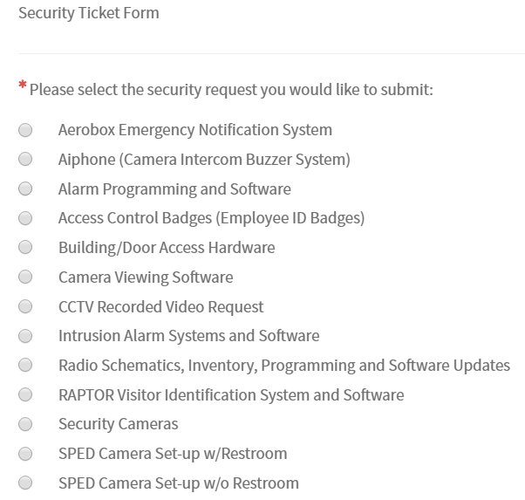

Each section may create additional boxes to select below it as you work through the help ticket. Make sure all questions are answered in as much detail as possible to expedite your request.

Please make sure to put the affected employee’s first and last name and employee ID number in the description of your problem section. There is a glitch in the system and we are not getting that information on the ticket.
Replacement/Lost Badge:

If your ID Badge is missing or lost please immediately contact your Administrator and Security Department so the badge can be deactivated. You can email securitysystems@aisd.net to have your badge deactivated and then your administrator can enter a help ticket as listed below if your badge is not found in 3-5 days. If your original badge is located after being reported lost: Call Security at 682-867-7839 so that the badge can be re-activated.

Service Now Request: This request must be made by a campus administrator (principal / AP). The administrator must make the request for a new badge with the Employee Name, Employee #, and Badge # after the 3-5 day grace period. The new badge will be sent to the administrator. Call Security at 682-867-7839 upon receipt of the badge to ensure it is activated.
CCTV Requests:

It is the responsibility of the campus needing video stored to review the video footage in question and indicate the camera information requested on the CCTV request form. Attach the CCTV request form to the help ticket so that we can preserve the footage.

Note:
Parent requests pertaining to SPED students with situations that happen in a SPED classroom with cameras must go through Paula Long's office. All other parents requesting a copy of video footage must go through the Arlington ISD Communications Department to complete the public information access request process.

